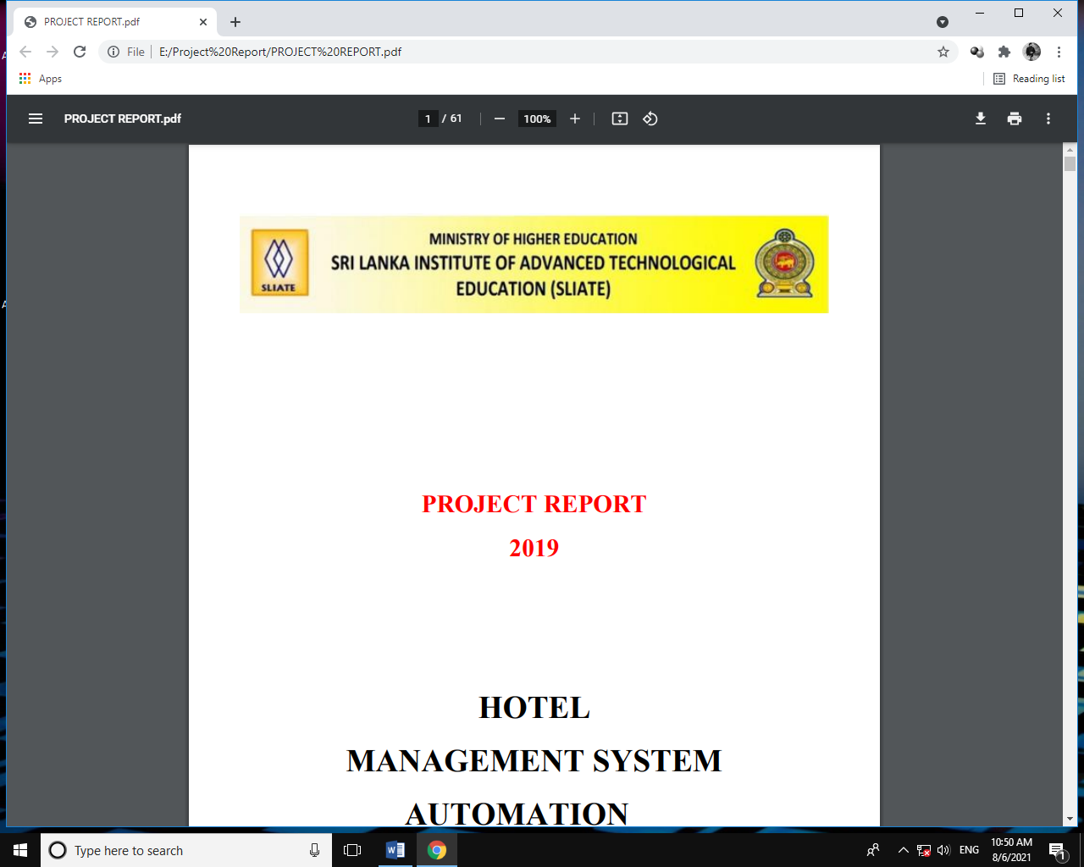

Madu River Safari Service Center Main

Management System

(Captain cruise Safari)

Project Report

High National Diploma in Information Technology

ATI - Labuduwa

# Developer Details

|  |  |  |  |
| --- | --- | --- | --- |
| Developer |  | : | N.Lahiru Pramod De Silva |
| Index |  | : | GAL-IT-2019-F-0005 |
| Batch |  | : | 2019(HNDIT) - Labuduwa |
| Email |  | : | Lahirupramod41@gmail.com |
| Contact |  | : | 075 7 250 546 |

# ACKNOWLEDGEMENT

In performing this project, we had to take the help and guideline of some respected persons, who deserve our greatest gratitude. We sincerely appreciate the inspiration; support and guidance of all those people who have been conduct in making this project success.

At this juncture we feel deeply honored in expressing our sincere thanks to Information Technology department lecturer MRS. Attanayake of supervisor and all the other lecturers of Information Technology department for making this project available at right time and providing valuable insights leading to the successful completion.

We would also like to thank all the HNDIT students of 19th batch for their critical advice and guidance.

# ABSTRACT

The objective of the project is to develop a Management System for Madu river boat safari service center to facilitate their management.

The project has been developed in HTML, CSS, JS, PHP, BOOSTRAP FRAMEWORK and consists of Xampp phpmyadmin server which acts as the database (sql) for the project. All the data needed for the Management System is stored in the form of the tables in the SQL server.

The report contains the details of the tasks carried out during the entire Web/Software development life cycle of the Captain cruise management system project. This document depicts all the details of the project.

Content

Contents

Developer Details 2

ACKNOWLEDGEMENT 3

ABSTRACT 4

**1.** **CHAPTER 1** 6

1.1. Introduction 6

1.2. Background 7

1.3. Purpose of Documentation 8

1.4. Aim and Objective 8

1.5. Scope of the project 9

1.6. User and System Requirement 10

**1.** **CHAPTER 2** 11

2.1. Review of Related Literature 11

2.1.1. Safari Management System and Related Management system 11

# **CHAPTER 1**

## Introduction

Madu River is a most beautiful river in Sri Lanka. Madu River is a minor [watercourse](https://en.wikipedia.org/wiki/Watercourse) which originates near [Uragasmanhandiya](https://en.wikipedia.org/wiki/Uragasmanhandiya" \o "Uragasmanhandiya) in the [Galle District](https://en.wikipedia.org/wiki/Galle_District) of [Sri Lanka](https://en.wikipedia.org/wiki/Sri_Lanka), before widening into the Madu River Lake at [Balapitiya](https://en.wikipedia.org/wiki/Balapitiya" \o "Balapitiya). The river then flows for a further a 4.4 km (2.7 mi) before draining into the [Indian Ocean](https://en.wikipedia.org/wiki/Indian_Ocean). It is located 88 km (55 mi) south of Colombo and 35 km (22 mi) north of [Galle](https://en.wikipedia.org/wiki/Galle).

The [Buddhist](https://en.wikipedia.org/wiki/Buddhist) [Amarapura Nikaya](https://en.wikipedia.org/wiki/Amarapura_Nikaya) sect had its first *upasampada* (higher ordination ceremony) on a fleet of boats anchored upon it in 1803. The Buddhist [Kothduwa temple](https://en.wikipedia.org/wiki/Kothduwa_temple" \o "Kothduwa temple) is situated on an isolated island in the lake.

Madu River Lake, together with the smaller Randombe Lake, to which it is connected by two narrow channels, forms the Madu River [wetland](https://en.wikipedia.org/wiki/Wetland" \o "Wetland).Its [estuary](https://en.wikipedia.org/wiki/Estuary) and the many [mangrove](https://en.wikipedia.org/wiki/Mangrove) islets on it constitute a complex coastal wetland [ecosystem](https://en.wikipedia.org/wiki/Ecosystem). It has a high [ecological](https://en.wikipedia.org/wiki/Ecological), [biological](https://en.wikipedia.org/wiki/Biology) and [aesthetic](https://en.wikipedia.org/wiki/Aesthetic) significance, being home to approximately 303 [species](https://en.wikipedia.org/wiki/Species) of plants belonging to 95 families and to 248 species of [vertebrate](https://en.wikipedia.org/wiki/Vertebrate) animals. The inhabitants of its islets produce peeled [cinnamon](https://en.wikipedia.org/wiki/Cinnamon) and cinnamon oil.

So this area has a major tourist attraction from both local and foreign sectors. And they are in the habit of visiting Madu River to have fun and gain knowledge about environmental diversity.

Then many tourist service centers have been set up in the area to cater to the needs of tourists. Captain cruise safari service center is also one of the medium scale tourist service center among them, and this project is developed for them.

## Background

As described above Captain Cruise Safari service center is medium scale tourist service center. Such a center uses a lot of special data and information every day. So they surely need a computerized system for maintain and manipulated this data and information very easy and safe.

But they still use physical document and journals. It’s very risky. Because these are built along river, Physical document and journals can be destroyed due to frequent flooding. Another special thing is the number of errors that occur during physical file processing is very high and fraud can happen.

So considering all the above, it was decided to develop a computerized web based system for the workspace.

## Purpose of Documentation

The main purpose of this vision document is to list the requirements of the Captain Cruise Management System project. This document also helps us to collect and analyze the ideas gathered for the project. This vision document will be subject to charge, if more requirements are added to the project. The document being prepared is the first version of vision document for the Captain Cruise Management System Project.

## Aim and Objective

The main objective of this project (CCMS) is Develop a computerized Management system for maintain and manipulated their data and information very easy and safe without any problem.

Aims –

* Decreasing the use of physical document.
* Eliminate fraud and corruption.
* Improving the security of documents.
* Saving employee costs and time.
* To win the trust of tourists.

## Scope of the project

This project (CCMS) is a computerized web based Management system for maintain and manipulated their data and information very easy and safe without any problem for Captain Cruise safari service center.

The system consist of several main modules and functions:

* Billing Module is a one of the main modules. It has main three functions: bill search function, bills prices automatic generate function and bill print and delete function. The main purpose of this is to issue the required bills to the customers. The system stores customer details, Traveling date and time, the number of passengers attending the tour, automatically calculated cost of tour and Details of the tour guide participating in the tour (this details are used to manage their salaries) .
* Prices Control Module is controlling all updates related to the bill pricing and payroll charges of the entire system. It has main two functions: Normal and Package price change function and Employee salary range change function. This function can only be used by authorized persons. For that reason this section has a special login system.
* Booking Module is used to record the details of the customers who have made advance reservation for a tour. It has main three functions: booking search function, Available date and time search function and move booking record to billing section and booking cancel function. The system stores customer details, Booking date and time, the number of passengers attending the tour.

## User and System Requirement

The minimum hardware and software requirements should be there in the computer system to deploy and operate the developed system successfully. These minimum requirements have been mentioned below,

#### Minimum Software Requirement

* + Any Browser (Chrome)
  + Good Internet Facilities.

#### Minimum Hardware Requirement

* + Desktop with intel i3 processor
  + 2gb ram , 1gb VGA
  + Wide screen monior , UPS

# **CHAPTER 2**



## Review of Related Literature



### Safari Management System and Related Management system